Tab Names:

* Home
* Election 2016
* Election 2020
* About

**[Tab: Home]**

**<h1> Unpacking Foreign Influence & Disinformation on Twitter**

<h2> Information Operations </h2>

<p> Actions by foreign governments to influence public opinion and intervene in internal political debates is not a new phenomenon. However, social networking platforms, such as Twitter, have allowed these information operation campaigns to run at scale, impacting a wider swath of the voting public. Foreign governments can use social media platforms to build a network of accounts and overtime, politicize them. These networks can be leveraged to promote disinformation and sew domestic discord.

<h2> Twitter’s Got Reach </h2>

<p> Twitter [reports](https://s22.q4cdn.com/826641620/files/doc_financials/2019/q1/Q1-2019-Selected-Company-Metrics-and-Financials.pdf) having more than 330 million monthly active users, making it one of the largest social networks worldwide. The United States represents the [biggest Twitter market](https://www-statista-com.ezp-prod1.hul.harvard.edu/statistics/242606/number-of-active-twitter-users-in-selected-countries/) with nearly 60 Million users projected by 2022.

<h2> So What? </h2>

<p> For individuals and governments invested in sewing seeds of discord among communities, targeting Twitter users is the perfect strategy. By leveraging a combination of bot and agent runTwitter accounts en masse, foreign entities are able to implement disinformation campaigns.

The goal is that the targeted communities they may act (or vote) based upon this false information. Twitter is in the process of discerning the scope of their responsibility in situations where state-sponsored disinformation campaigns have a remarkable reach. One step they’ve taken is to suspend accounts they deem to be a part of these campaigns. Additionally, in the name of transparency, Twitter has committed to releasing information about these accounts, including their tweets. Below is a chart capturing the information Twitter has made publicly available on these campaigns.

[insert D3 visualization]

[Insert button that goes to the right, i.e next page]

*~* [*creative commons illustration*](https://search.creativecommons.org/photos/0bc487b4-e42f-47d9-a421-e0a206fa4949)*~*

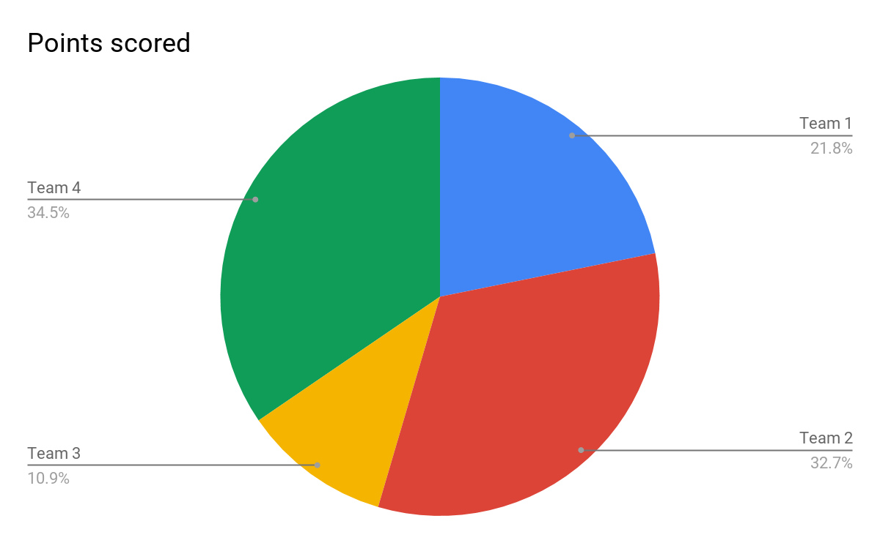

***What’s included?***

***These datasets include all public, nondeleted Tweets and media (e.g., images and videos) from accounts we believe are connected to state-backed information operations. Tweets deleted by these users prior to their suspension (which are not included in these datasets) generally comprise less than 1% of their overall activity. Note that not all of the accounts we identified as connected to these campaigns actively Tweeted, so the number of accounts represented in the datasets may be less than the total number of accounts listed here.***

***[Tab 2016]***

**<h1> 2016 Election**

**<h2>Russia Influence Operations on Twitter**

<p>The Internet Research Agency (IRA) is a Russian entity that runs social network information operations for the Kremlin. The IRA is known for the systematic creation and operation of fake accounts on social media sites in order to promote the states interest abroad.The Muller Report on interference in the 2016 US Presidential Election highlights the actions of the IRA took to sow political discord on divisive domestic issues. Twitter proved to be a successful platform for the IRA, with a report from twitter showing that **1.4 million people interacted with Russian trolls in the lead up to the 2016 election**.

<p> To promote research into disinformation, Twitter has released datasets containing the tweets of identified accounts created for state sponsored information operations. The data visualized below come from a random sampling of english tweets from the 3,613 accounts and 10 Million tweets affiliated with the IRA.

<> By sorting the data into unique user ID we can see when each IRA rub account was created.

**<h1> When did this all start?**

*~ visualization: account creation date ~*

**

<p> A large portion of these accounts were created years before the election day in 2016. Showing that Russia was not afraid to play the long game in their attempt to influence US politics.

**<h2> Who were these tweets were talking about?**

*~ visualization: mention % ~*

**

<p> The tweets talked about subjects ranging from sports to #blacklivesmatter protests. A large portion of the content was not political. But when it was, Trump was the center of discussion. Though members of the democratic party were not far behind

<p Writing 10M tweets sounds like a lot of work. Lets look at much of the IRA’s contents was retweeting existing sentiments compared to writing their own hot takes.

**<h2> How were these political figures portrayed?**

<p> We used an open source natural language processing tool called TextBlob to run a sentiment analysis on the tweets. The results can show if the Kremlin was trying to promote a positive or a negative view of the two 2016 candidates.

The results suggest that the primary strategy of the IRA was not to blindly support Trump, but rather promote divisiveness about both candidates.

that strategy of IRA was to

*~ visualization: sentiment of hillary vs trump ~*

*~Image of select tweets~*

<p> ...divisiveness …

**[Tab 2020]**

<h1> 2020 Election

**

<body>

How are the agents of disinformation operating before the 2020 elections? Has technology companies done enough to hem the flow of disinformation on social media?

In the 7th and last Democratic Debate, we analyzed a sample of Twitter data to measure the sentiment of twitter users about some of the top candidates for the presidency.

<iframe title="7th Democratic Debate Sentiment Analysis" aria-label="Stacked Bars" id="datawrapper-chart-E4iay" src="//datawrapper.dwcdn.net/E4iay/1/" scrolling="no" frameborder="0" style="width: 0; min-width: 100% !important; border: none;" height="409"></iframe><script type="text/javascript">!function(){"use strict";window.addEventListener("message",function(a){if(void 0!==a.data["datawrapper-height"])for(var e in a.data["datawrapper-height"]){var t=document.getElementById("datawrapper-chart-"+e)||document.querySelector("iframe[src*='"+e+"']");t&&(t.style.height=a.data["datawrapper-height"][e]+"px")}})}();</script>

Some portion of the hashtags trending after the debate were created by “troll_bots,” which are real people or twitter bots that share misrepresented or fake information on twitter.

How prevalent are these troll_bots on Twitter? Some hashtags are much more active with troll_bots than others. In our analysis, for #MAGA and #MAGA2020 over 30 percent of twitter users using this hashtags were troll_bots. For other hashtags, such as #NeverWarren, the number is lower at 2 percent.

<iframe title="What percentage of twitter activity are trollbots?" aria-label="Bar Chart" id="datawrapper-chart-OqHKk" src="//datawrapper.dwcdn.net/OqHKk/1/" scrolling="no" frameborder="0" style="width: 0; min-width: 100% !important; border: none;" height="355"></iframe><script type="text/javascript">!function(){"use strict";window.addEventListener("message",function(a){if(void 0!==a.data["datawrapper-height"])for(var e in a.data["datawrapper-height"]){var t=document.getElementById("datawrapper-chart-"+e)||document.querySelector("iframe[src*='"+e+"']");t&&(t.style.height=a.data["datawrapper-height"][e]+"px")}})}();</script>

Some of the most influential tweets shared by troll_bots are Trump’s tweets. However, other high engagement tweets by troll_bots reinforce far right ideas and opposition to liberal politicians and activists.

<blockquote class="twitter-tweet"><p lang="en" dir="ltr">The corrupted Dems trying their best to come to the Ayatollah&#39;s rescue.<a href="https://twitter.com/hashtag/NancyPelosiFakeNews?src=hash&amp;ref_src=twsrc%5Etfw">#NancyPelosiFakeNews</a> <a href="https://t.co/a0ksPHeXCy">pic.twitter.com/a0ksPHeXCy</a></p>&mdash; داون آندر (@D0wn_Under) <a href="https://twitter.com/D0wn_Under/status/1216667026191605760?ref_src=twsrc%5Etfw">January 13, 2020</a></blockquote> <script async src="https://platform.twitter.com/widgets.js" charset="utf-8"></script>

<blockquote class="twitter-tweet"><p lang="en" dir="ltr">BREAKING: <a href="https://twitter.com/BernieSanders?ref_src=twsrc%5Etfw">@BernieSanders</a> “free education” policies to “teach you how to not be a f**king nazi.”; &#39;There is a reason Stalin had Gulags&#39;; &#39;Expect violent reaction&#39; for speech. If Bernie doesn&#39;t get nomination &quot;Milwaukee will burn&quot;<br><br>Stay tuned: <a href="https://t.co/BFGnoCeJE7">https://t.co/BFGnoCeJE7</a><a href="https://twitter.com/hashtag/Expose2020?src=hash&amp;ref_src=twsrc%5Etfw">#Expose2020</a> <a href="https://t.co/Koh6UTibbe">pic.twitter.com/Koh6UTibbe</a></p>&mdash; James O&#39;Keefe (@JamesOKeefeIII) <a href="https://twitter.com/JamesOKeefeIII/status/1217083949693968385?ref_src=twsrc%5Etfw">January 14, 2020</a></blockquote> <script async src="https://platform.twitter.com/widgets.js" charset="utf-8"></script>

<blockquote class="twitter-tweet"><p lang="en" dir="ltr">Facebook had a glitch that allowed users to see Greta Thunberg’s account was being run by her dad &amp; a climate activist in India.<br><br>Lmao....<br><br>This just confirms what we already knew - she’s a puppet who is being used by her parents &amp; handlers to push a destructive global agenda.</p>&mdash; Educating Liberals (@Education4Libs) <a href="https://twitter.com/Education4Libs/status/1216786948775469062?ref_src=twsrc%5Etfw">January 13, 2020</a></blockquote> <script async src="https://platform.twitter.com/widgets.js" charset="utf-8"></script>

**[Tab: About]**

**<h1> About the project**

<p> … code4policy class..

**<h1> Meet the Team**

<h2> Anissa Abdel-Jelil

<h2> Rasim Alam

<h2> Jackie Faselt

Burn Down Chart: (Tasks as of 01/17/20)

Tasks Completed on:

Sprint 1

01/10/20 - Sum: 6 (2, 1, 3)

01/11/20 - Sum: 2

01/12/20 - Sum: 3

01/13/20 - Sum: 9 (2, 2, 5)

01/14/20 - Sum: 24 (5, 5, 8, 3, 1, 2)

Sprint 2

01/15/20 - Sum: 0

01/16/20 - Sum: 1

01/17/20 - Sum: 5

01/18/20 - Sum: 28- 5, 3, 3, 5, 5, 5, 2 (up to 35)

01/19/20 - Sum: 4

